Super Hospital System

By Team ABoT (Always Be on Time)

Final Document

Aadil Alladina

Dustin Green

Ketra King

John Rucker

Don Squirek

Table of Contents

1. Introduction
2. Operating system requirements
3. Process Overview

1. Introduction

Our software is designed primarily for use large hospitals. It contains all the functionality a hospital needs for tracking both staff and patient information, but its signature feature is its ability to access an extensive database of both medicinal and recreational drugs. Currently, any time a staff member needs to access information about the various chemical compounds hospitals deal with daily, they must consult the giant book of drugs. We wanted to put all that information at the staff’s fingertips, thereby improving the speed at which staff could access vital drug information, and reducing any chance of errors like referring to the wrong page or entry in the book. We felt that this would not only make life easier for doctors and nurses, but would also greatly improve the quality of patient care. This extensive drug database, together with the core functionality provided to the hospital staff, makes up the base of our software project.

In addition however, our software will also have the ability to read data directly from hospital equipment, allowing nurses and doctors to keep an eye on their patients’ condition and vital signs even when in another room or floor. This functionality is currently not active, but will be activated upon getting a contract and learning what equipment we need the software to integrate with. Coupled with this functionality is the software’s ability to signal the doctor and/or nurses assigned to a patient whose condition has worsened. This functionality is also disabled until vitals reader is complete and working.

On the other side of the hospital from the nurses and doctors are the pharmacists and system administrators. Our system is designed to give a lot of functionality while still being uncluttered and intuitive, and its functions for staff not involved in patient care is no exception. For system administrators, our software relies on SQLite databases for efficiency and ease of use, allowing them to both and remove entries from the databases either by working on the database directly or through our software. On the pharmacist end, our system features the ability to track what medicines the pharmacy does have in stock and provides functionality for doctors to request medicine from the pharmacy, with an alert to the nurse on duty when the prescription has been filled. Pharmacists are also capable of updating the drug database with new entries as new medicines and new recreational drugs come into existence.

All in all, our Super Hospital System will provide everything a large hospital needs in order to run efficiently, and provides the framework for the staff to grow closer as a well trained team. We believe this will greatly improve patient care, as well as making life easier for the staff. We want to make hospitals a better place, and that’s why we came up with the Super Hospital System.

1. System requirements

|  |  |  |  |
| --- | --- | --- | --- |
|  |  | **Component** | **Requirement** |
|  |  | Operating System | Windows XP, Windows Vista, or Windows 7 |
|  |  | Processor | AMD Athlon 64 X2 Dual-Core 4000+ or better  or  Intel Celeron Processor 2.0GHz or better |
|  |  | RAM | 512MB |
|  |  | Graphics | ATi Radeon or better  or  NVIDIA GeForce or better |
|  |  |
|  |  |

1. Process Overview

The SHS is to be a software system that monitors patients' vitals and medications, and keeps track of their location according to their schedule. It is also to keep staff informed of their schedule, and issue alerts if there is a negative change in a patient's status.

**General Use**

Users (doctors, nurses, and administrators) shall log in by entering their user name and password into the GUI window. The software shall check this information against a database containing all the staff's login information. If the entered information is incorrect, the software shall return the user to the login screen and prompt for the correct user name and password. The software shall allow users to reset their passwords by using security questions to authenticate their identity. Upon successful login, the software shall bring the user to the software's home screen.

*************************************************************************

* Supieror Hospital Systems

* By: Always be on Time

* Text Based Instructions

************************************************************************

**Doctors**

Logging in as a doctor shall allow the doctor to view a list of panels, each with a single patient's name on it. When the doctor selects a panel, the software shall bring the doctor to a new window containing all patient information, including diagnosis, medications, and next appointment.

Step 1: Doctors Menu

Enter a username and password

Username: doc1

Password: 111

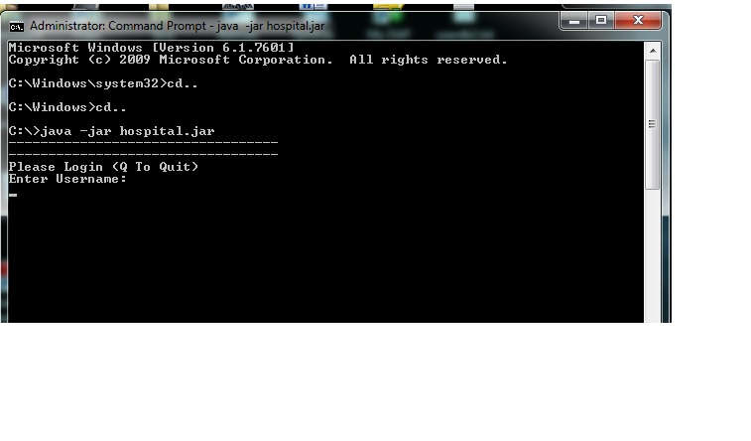

Press Enter and you will be routed to the Doctors Menu:

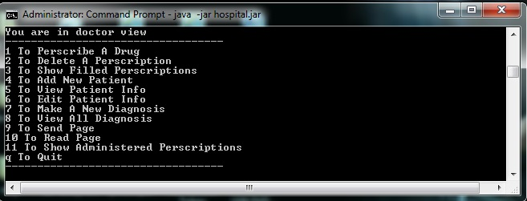

Press option 1 to prescribe a drug then enter the PATIENT ID listed on the left side

-once the patient is selected you will be prompted to enter the drug you would like to prescribe.

-if the drug is not found a warning will be posted “Drug Not Found” and you will be prompted again with the Doctors Menu.

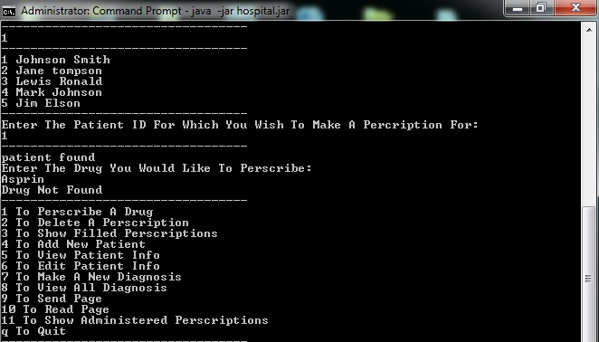

Press option 1 to prescribe a drug then enter the PATIENT ID listed on the left side

-once the patient is selected you will be prompted to enter the drug you would like to prescribe.

- If the drug is not in the pharmacy database you will be prompted with a notification that the drug was not found and routed back to the Doctors Menu.

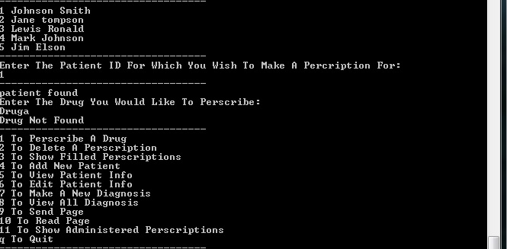

Press option 1 to prescribe a drug then enter the PATIENT ID listed on the left side

-once the patient is selected you will be prompted to enter the drug you would like to prescribe.

- If the drug is in the database you will be prompted to enter a dosage. If there is a conflict a warning will post and ask you to continue with prescription or not. Once a selection is made you will be sent back to the Doctors Menu.

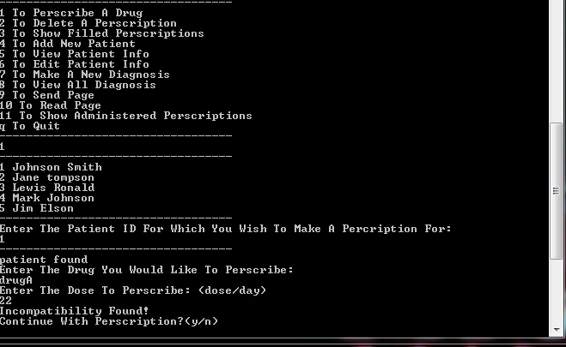

Press Option 2 to delete a prescription

Press Option 3 to show filled prescription

Press Option 4 to add new patients

-You will be prompted to enter their full name telephone number

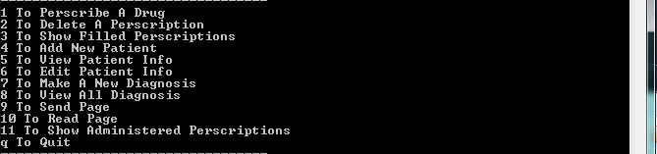

Press Option 5 to view patient info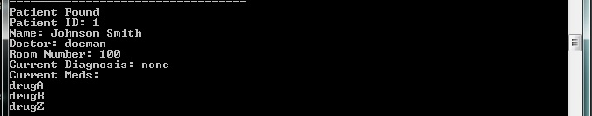

Press Option 6 to edit the patient info



Press Option 7 to make a new diagnosis

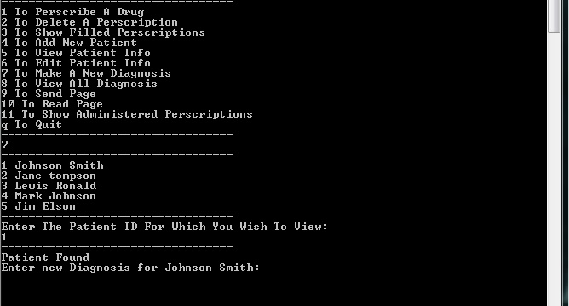

Press Option 8 to view all diagnosis

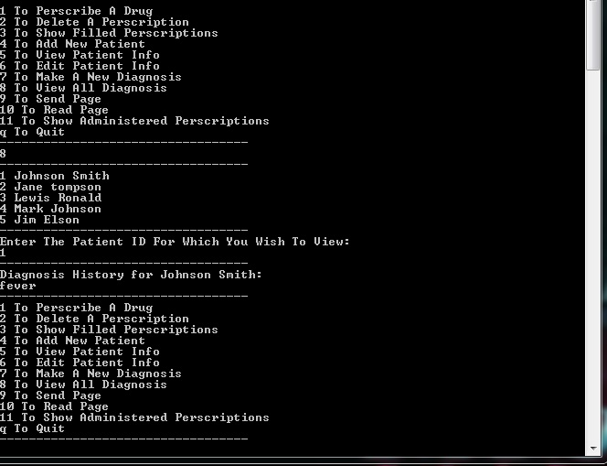

Press Option 9 to send notification to another user in the system(Nurse or Doctor).

-you will be prompted for a username of the person you want to page

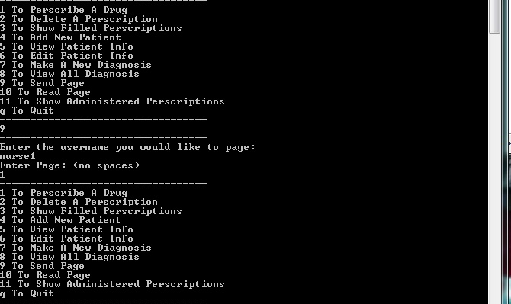

Press Option 10 to read notificationsfrom another user in the system(Nurse or Doctor).

-you will be prompted for a username .

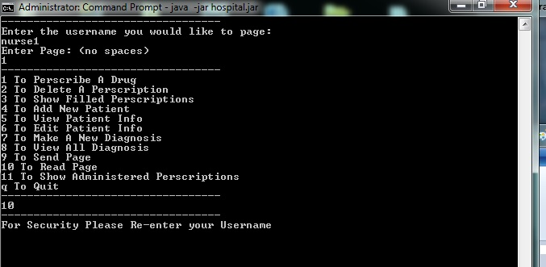

Press Option 11 to show administered prescriptions

Press Q to be logged out back to main screen

**Nurses**

Logging in as a nurse shall allow the nurse to view a list of room numbers in their ward and patient names for each room. When the nurse selects a panel, the software shall bring the nurse to a new window containing patient name, diagnosis, medications, and next check-up.

Username: nurse1

Password: 222

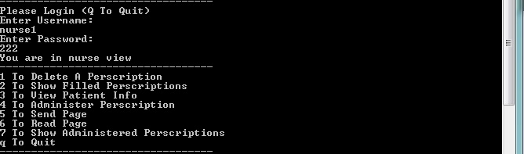

Press 1 to delete a prescription if found in database

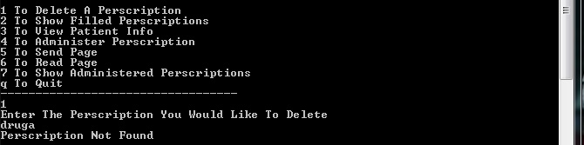

Press 2 to show filled prescription

---if there are any

Press 3 view patient information

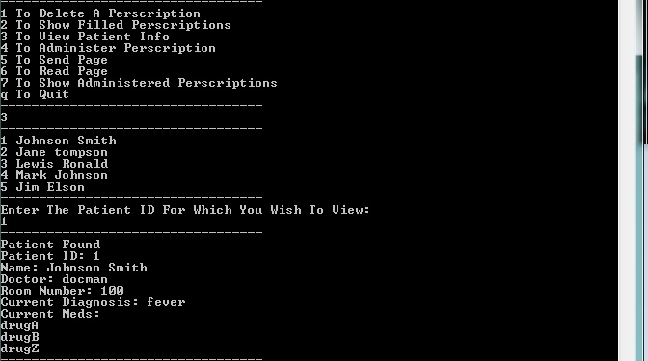

Press 4 to administer prescription

--you will be prompted for the patients name

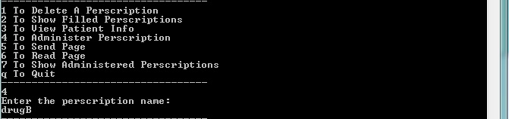

Press 5 to send notification

--you will be prompted for the username you are trying to page

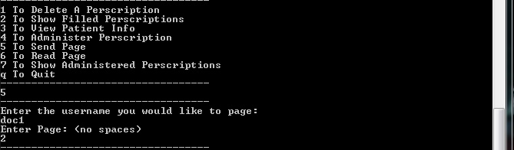

Press 6 to read notification

--security prompt

Press 7 to show administered prescriptions

Press Q to be logged out back to main screen

**Pharmacy**

Logging in as a pharmacist allows the user to add, edit, and delete drugs in the system. Also view drug stock, fill and delete a prescription and show the current prescription.

Login with username pharmaacy1

password 444

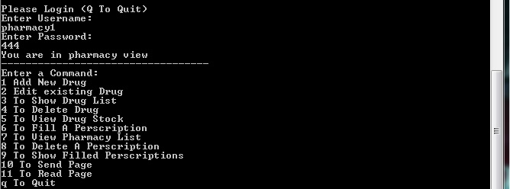

Press 1 for Add Drug

* Enter details for the new drug to be added to the pharmacy

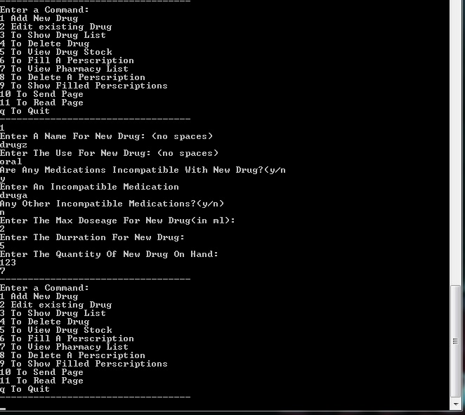

Press 2 to edit drug details

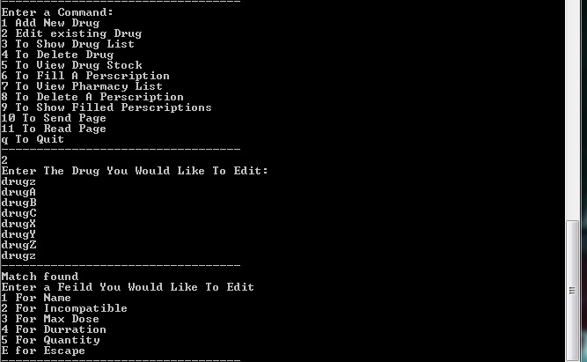

Press 3 to show drug list of the pharmacy

Press 4 to delete a drug

Press 5 to view drug stock

Press 6 to fill a prescription

Press 7 to view pharmacy list

Press 8 to delete a prescription

Press 9 to show filled prescription

Press 10 to send a page

Press 11 to Read page

**Administrator**

Administrators shall be able to create and remove users from the login database. Permission level for users shall be assigned by the administrator according to job position.

**Note when creating new users permissions the can to be entered in as admin, nurse, doctor, or pharmacy. Permission assignment is CASE SENSATIVE**

Login with

Username: admin1

Password: 333

You will be presented with the below options.

Press 1 to add a new user and there permission level(admin, doctor, nurse, and pharmacy)

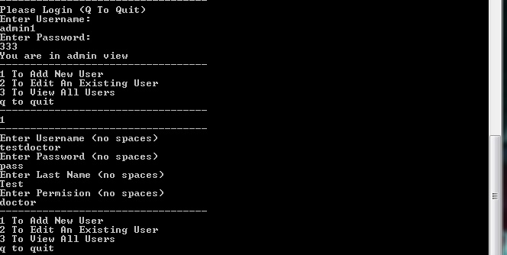

Press 2 to edit the users account

Press 3 to view all users in the system

Press q to QUIT the system

************************************************************************* *

* Supieror Hospital Systems *

* By: Always be on Time *

* Text Based Instructions *

************************************************************************

1.) open a command line window

2.) make sure patientdb.txt userdb.txt and drugdb.txt are in the directory:"F:\hospital\"

2.) enter java -jar

3.) followed by the path to the jar file

4.) if program encounters an error with loading the db the program will prompt for a new path to the database

this is most likely due to a differnly named external drive. The default path is F:\\hospital\\"dbname"

So to fix this error simple locate the drive name being read from and re enter the path name

ex: if your drive is a "G" drive your will enter: G:\\hospital\\ The program will then run normally.

**Note when creating new users permissions the can to be entered in as admin, nurse, doctor, or pharmacy. Permission assignment is CASE SENSATIVE**

THIS ENDS THE INSTRUCTIONS TEXT BASED GUI FOR:

Supieror Hospital Systems

GUI BASED INSTRUCTIONS

Double click on

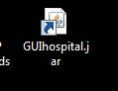

Press

* Enter System to enter system
* Exit System to exit system

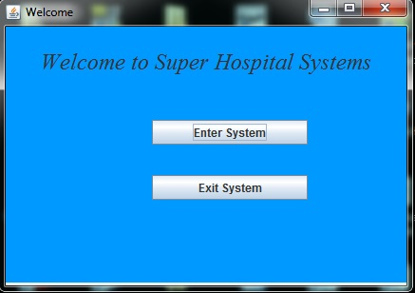

Enter your username and password

Step 1: Doctors Menu

Enter a username and password

Username: doc1

Password: 111

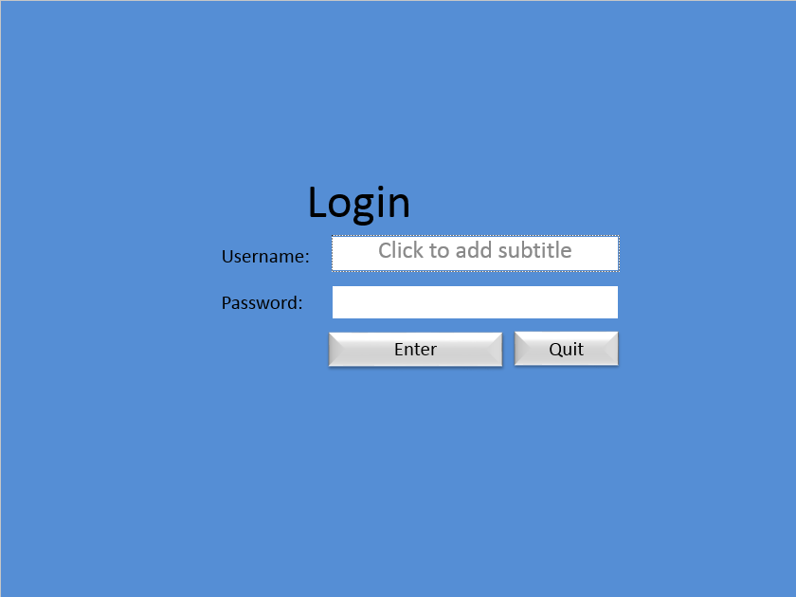

If the username and/or password are incorrect or not present in database you will receive the below error.

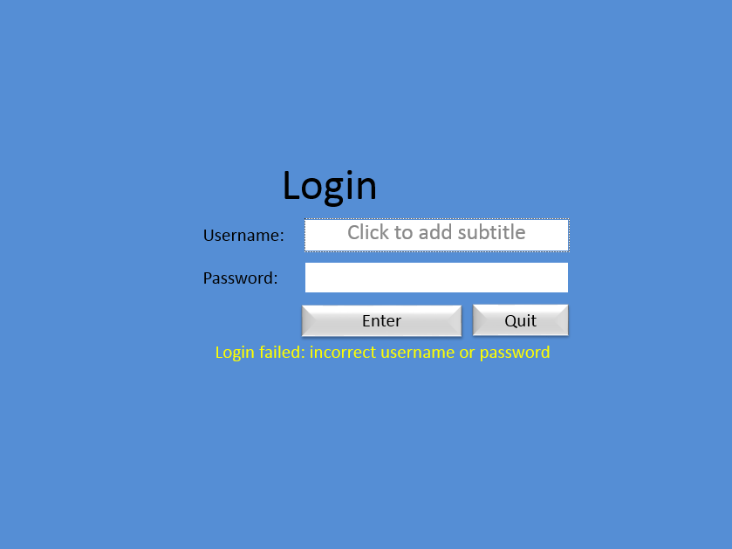

Doctors Menu

Select a paitent

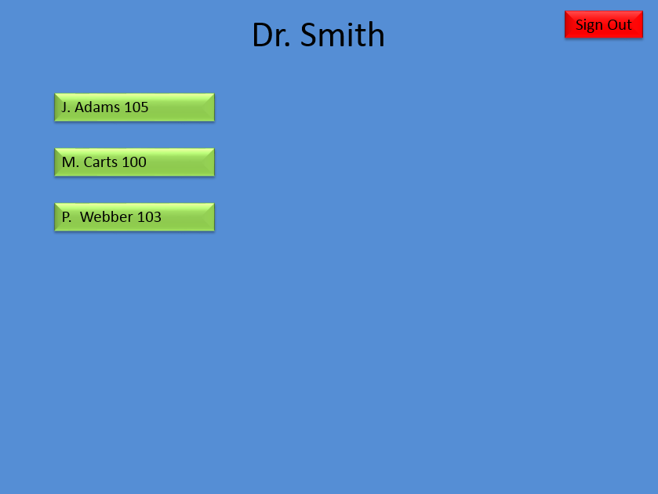

Patients information can be updated and drugs can be prescribed and sent to the PHARMACY.

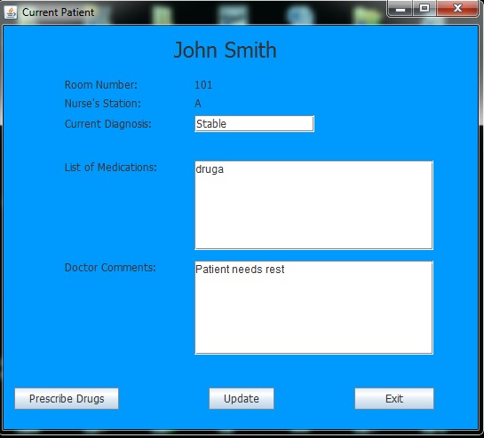

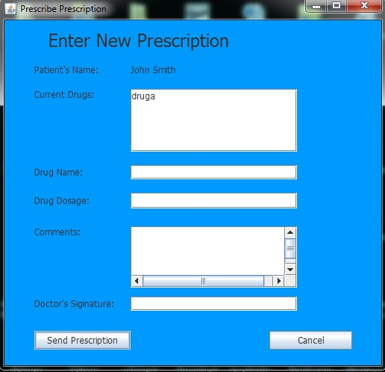

Press sign cancel and RED X to be brought back to the patient screen



Press Sign Out

Nurse Login

Username: nurse1

Password: 222



Nurse menu

-Select a Paitent

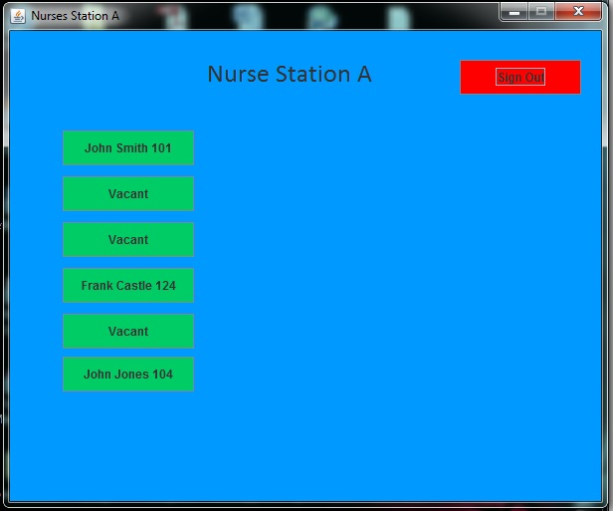

Patient information can be viewed and edited

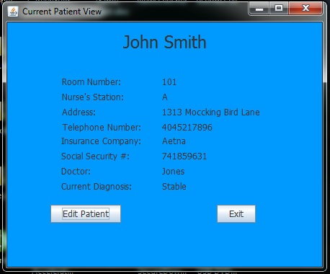

When pressing Vacant the user is prompted to enter information for a new patient



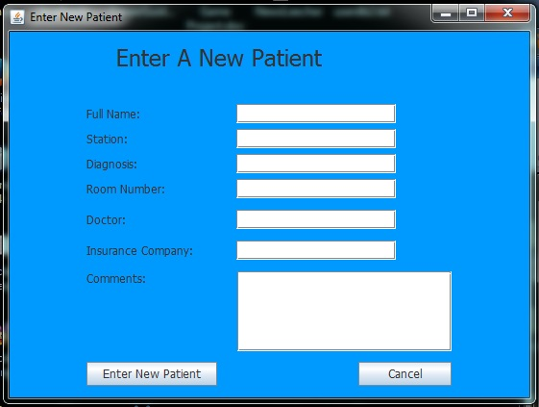

Once entered press ENTER NEW PATIENT or cancel and you will be routed back to NURSE screen. Press Sign Out



**Pharmacy**

Login username: pharmaacy1

password 444



Here the Pharmacist can click

* Fill Prescription
* Enter New Drug
* Edit Drug
* Delete Drug

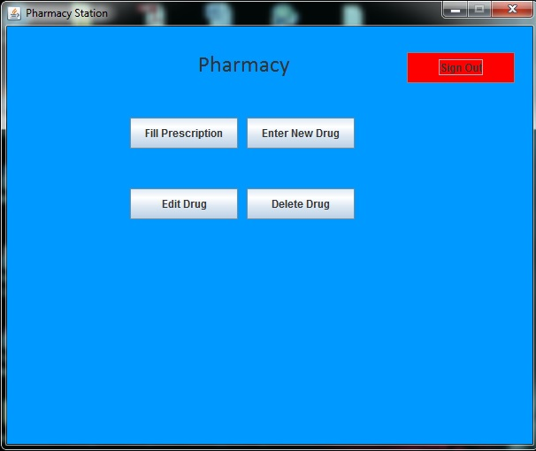

Fill Prescription

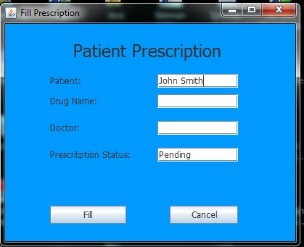



Enter New Drug

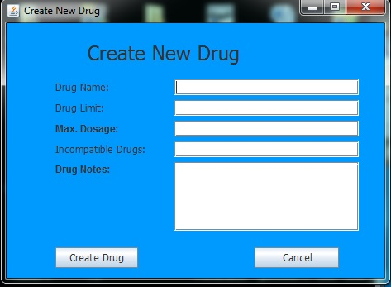



Edit Drug

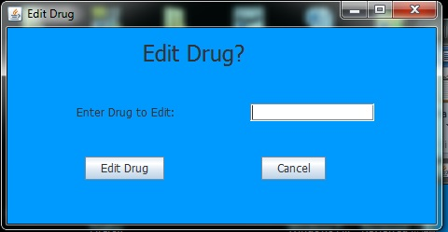



Delete Drug

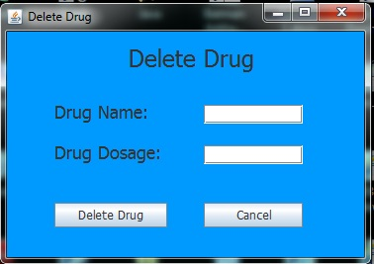



Press Sign Out



**Administrator**

Login with

Username: admin1

Password: 333

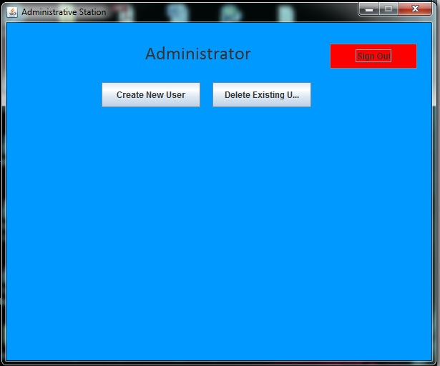

Press Create New User

--Note when creating new users permissions the can to be entered in as Administrator, Nurse, Doctor, or Pharmacist. Permission assignment is CASE SENSATIVE

Press Enter or Cancel

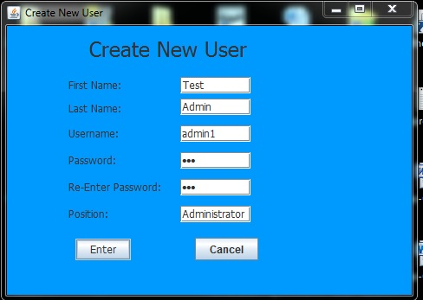

User will be brought back to Administrator screen



Press Delete User

--search by users first and last name and USERNAME

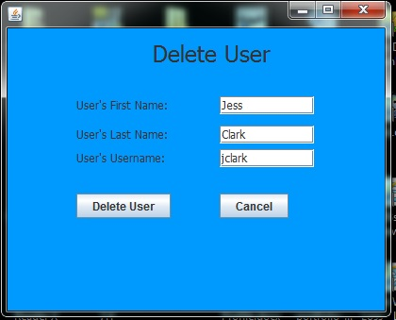

Press Delete User or Cancel will exit back to



Press Sign Out



This ENDS the users guide